**Project Details**

|  |  |
| --- | --- |
| Project number | *9* |
| Project title | *Mega store corporation* |
| Corresponding TA\LA | *LA\Alia Magdy* |
| Deliverable | *2* |

**Team Details**

|  |  |  |
| --- | --- | --- |
| **Student ID** | **Student name** | **Lab Group** |
| 20201203 | Nourhan Amr Abd El-Wahab | S6 |
| 20201189 | Nada Emad Mohammed | S8 |
| 20201041 | Aya Hasanin sayed | S6 |
| 20201191 | Nada Mohammed Ahmed | S1 |
| 20200606 | Nour Yasser Mahmoud | S6 |
| 20201182 | Mai Tarek Ahmed | S8 |
| 20200522 | Mariam Tarek Galal | S5 |

1. **CRUD technique:**

Verify use cases using the CRUD technique (e.g., Fig 5-12)

|  |  |  |
| --- | --- | --- |
| Domain Class | CRUD | Verified Use case |
| customer | create | Enter country  Enter location |
|  | update | Gain points |
|  | Read\report | uses offers  Choose category |
|  | delete | Deactivate account |
| Search History | Read/report | Enhance services |
|  | Create/update | Search for the exact product |
| Marketing subsystem | Create/update/delete | Provide special bags |
|  | Read/update | Return product |
| Pay by cash | create | Pay cash |
|  | Read/report | Take bill |
|  | update | Enhance services |
|  | delete | Confirm payment |
| Pay by visa | create | Pay visa |
|  | Read/report | Request visa password  Take bill |
|  | update | Enhance services |
|  | delete | Confirm payment |
| Pay by point | create | Pay point |
|  | Read/report | Detecting if the customer has enough points |
|  | update | Enhance services |
|  | delete | Confirm payment |
| Different services | create | Provide different services |
|  | Read/report | Enter country  Enter location |
| product | create | Provide product |
|  | Read/report | Search for the exact product |
|  | Update/delete | Return product |
| supplier | Create/update/delete | Enter name  Enter number |
|  | read | Provide product |
| offers | Create/update/delete | Manage offers |
|  | Read/report | Uses offers |
| warehouse | Create/update/delete | Manage warehouse |
|  | Read/report | Return products |
| organizer | Create/update/delete | Enter organizer information |
|  | Read/report | Return products  Search for exact products |
| admin | Create/update/delete | Enter admin information |
|  | Read/report | Choose payment method  Enter country |
| payment | create | Choose payment method |
|  | update | Gain points  Update payment information |
|  | Read/report | Check payment information |
|  | delete | Update payment information |
| category | create | Choose category |
|  | Update/delete | Support many categories |
|  | Read/report | Look up category |

CRUD table showing use cases and corresponding domain classes (e.g., Fig 5-13)

|  |  |  |  |  |  |  |  |  |  |
| --- | --- | --- | --- | --- | --- | --- | --- | --- | --- |
| **Use case vs Domain Class** | **supplier** | **product** | **offers** | **payment** | | **Pay by visa** | **Pay by cash** | | **Pay**  **By**  **point** |
| Pay cash |  |  |  |  | | C |  | |  |
| Pay visa |  |  |  |  | |  | C | |  |
| Pay point |  |  |  |  | |  |  | | C |
| Take bill |  |  |  |  | | R | R | | R |
| Enhance services |  |  |  |  | | U | U | | U |
| Confirm payment |  |  |  |  | | D | D | | D |
| Request visa password |  |  |  |  | |  | R | |  |
| Detecting if the customer has enough points |  |  |  |  | |  |  | | R |
| Provide product | R | C |  |  | |  |  | |  |
| Enter name | C/U/D |  |  |  | |  |  | |  |
| Enter number | C/U/D |  |  |  | |  |  | |  |
| Search for the exact product |  | R |  |  | |  |  | |  |
| Return product |  | U/D |  |  | |  |  | |  |
| Manage offers |  |  | C/U/D |  | |  |  | |  |
| Uses offers |  |  | R |  | |  |  | |  |
| Choose payment method |  |  |  | C | |  |  | |  |
| Gain points |  |  |  | U | |  |  | |  |
| Update payment information |  |  |  | U/D | |  |  | |  |
| Check payment information |  |  |  | R | |  |  | |  |
| **Use case vs Domain Class** | **Customer** | **Search History** | **warehouse** | **Different services** | **admin** | | | **organizer** | |
| Enter country | C |  |  | R | R | | |  | |
| Enter location | C |  |  | R |  | | |  | |
| Gain points | U |  |  |  |  | | |  | |
| Uses offers | R |  |  |  |  | | |  | |
| Choose category | R |  |  |  |  | | |  | |
| Deactivate account | D |  |  |  |  | | |  | |
| Search for the exact product |  | C/U |  |  |  | | | R | |
| Enhance services |  | R |  |  |  | | |  | |
| Manage warehouses |  |  | C/U/D |  |  | | |  | |
| Return products |  |  | R |  |  | | | R | |
| Provide different services |  |  |  | C |  | | |  | |
| Enter admin information |  |  |  |  | C/U/D | | |  | |
| Choose payment method |  |  |  |  | R | | |  | |
| Enter organizer information |  |  |  |  |  | | | C/U/D | |

|  |  |  |
| --- | --- | --- |
| **Use case vs Domain class** | **Marketing subsystem** | **Category** |
| Provide special bags | C/U/D |  |
| Choose category |  | C |
| Support many categories |  | U/D |
| Look up category |  | R |

1. **Domain class model**

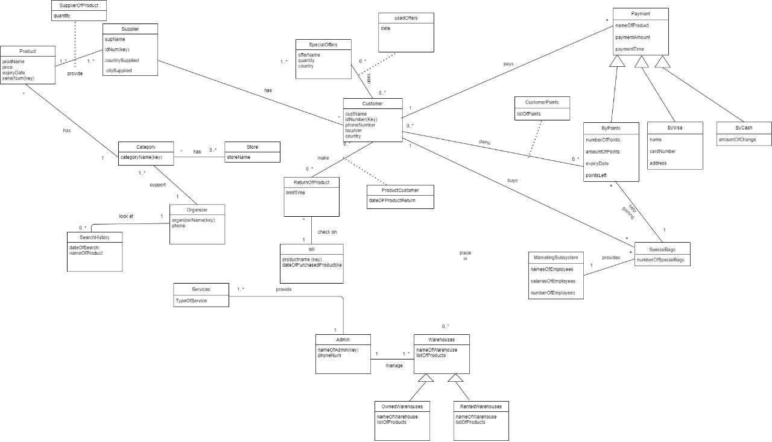

1. **State Machine Diagram**

1. **Activity Diagrams**

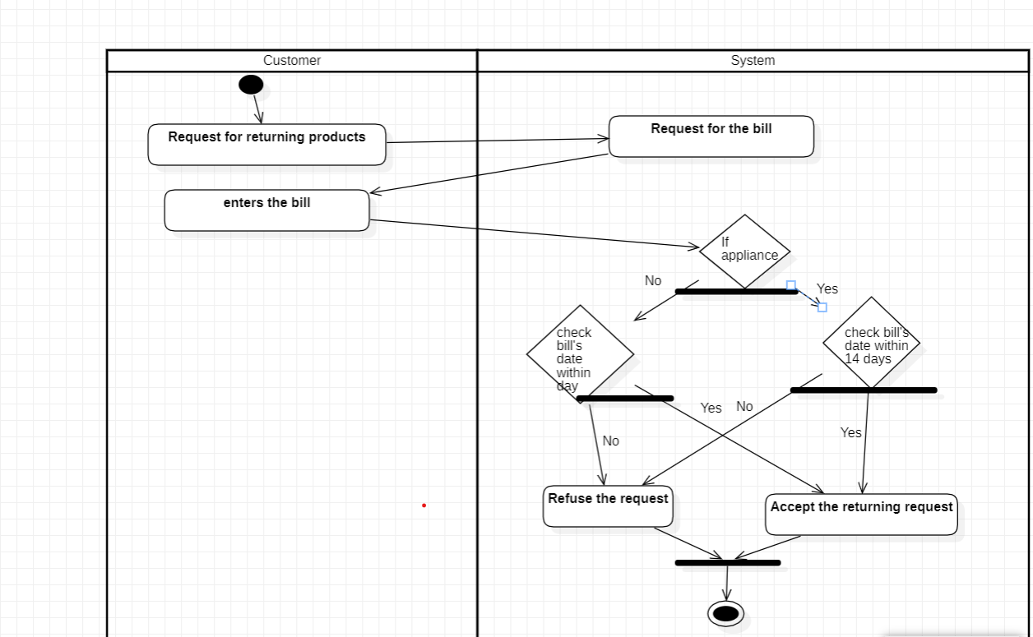

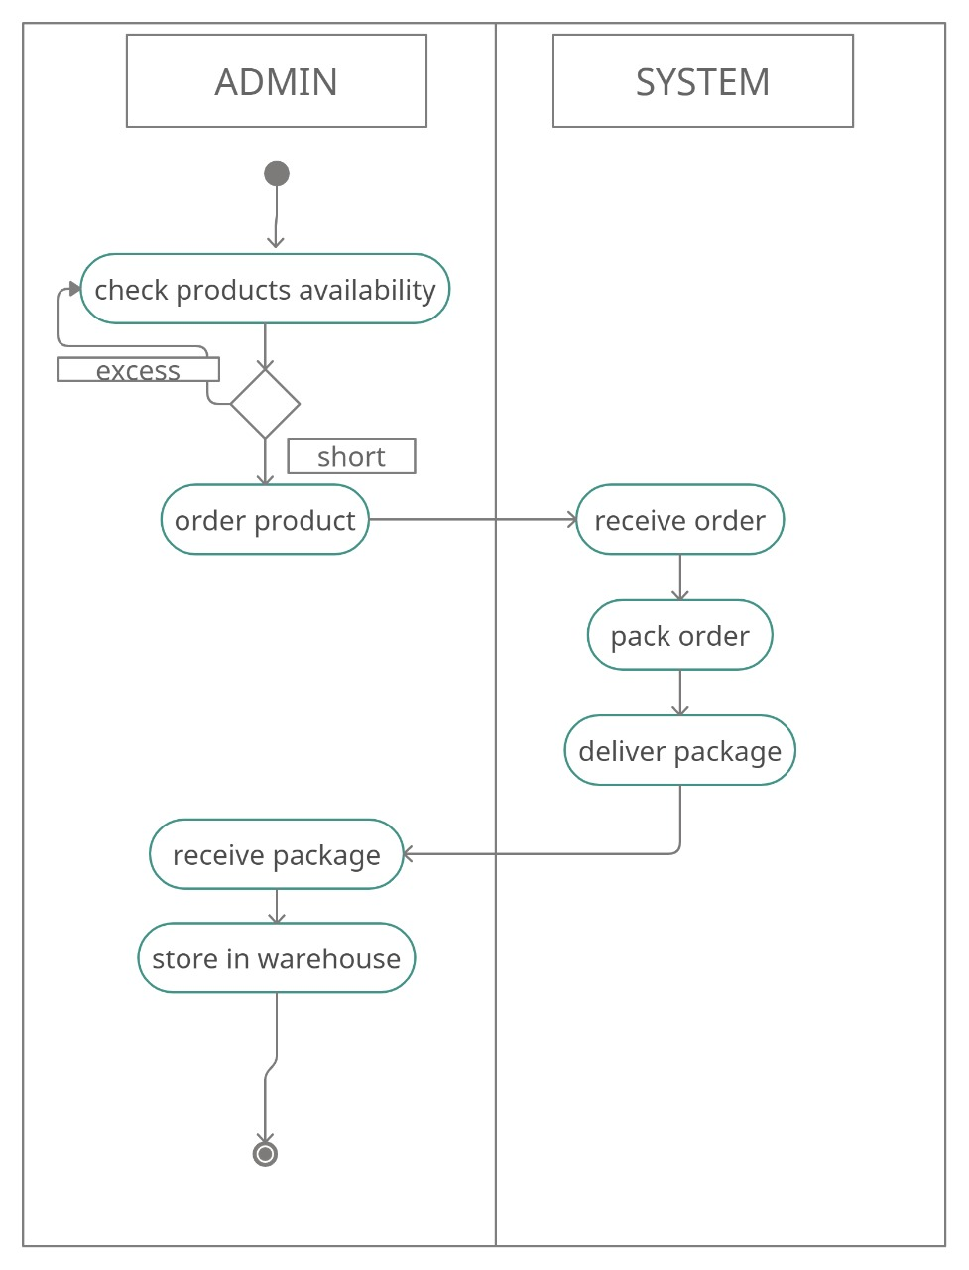

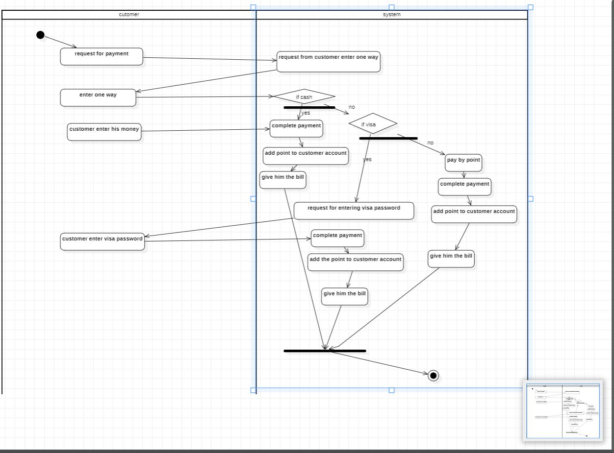

1. **Sequence Diagrams**



